
EXAMPLE Risk Assessment Report

Risk Assessment Report

DOCUMENT REF | RISKASS-002
VERSION | 1
DATED | 21 September 2021
DOCUMENT AUTHOR | Thomas Jones
DOCUMENT OWNER | John Doe – BC Manager

Revision history
VERSION | DATE | REVISION AUTHOR | SUMMARY OF CHANGES
1 | 20.5.20xx | John Doe | First Version

Distribution
NAME | TITLE
Mark Evans | CEO
Phil Tucker | Facilities Manager
Ken Clarkson | IT Manager

Approval
NAME | POSITION | SIGNATURE | DATE
Bill Smith | COO |  | 22.5.20xx

Contents
1 Introduction 4
2 Risk assessment context 5
2.1 Internal and external context 5
2.2 Scope 5
2.3 Risk assessment process 6
2.4 Risk acceptance criteria 6
3 Risk assessment results summary 7
4 Appendix A: Detailed risk assessment 9

Figures
Figure 1: Screenshot of the risk assessment tool 9

Tables
Table 1: Risk assessment team 4
Table 2: People consulted 4
Table 3: Prioritized business activities 5
Table 4: Risk assessment summary 8

Introduction
In order to fulfil its mission to the customers and other stakeholders it serves, JJ & Sons must ensure that the key products and services it provides are protected from risk. This requires that the people, processes and technology that provide its services are protected as far as possible against disruptive incidents that may arise which could affect their ability to operate.
The purpose of this document is to assess the main risks to JJ & Sons’ prioritised activities and the processes, systems, information, people, assets, outsource partners and other resources that support them and then to identify a set of actions that should be put in place to address these risks. These actions will be managed as part of the Business Continuity Management System (BCMS).
This risk assessment has been produced as part of the implementation of ISO22301 international standard for business continuity management within JJ & Sons.
This risk assessment was carried out by the following people:
NAME | ROLE IN ASSESSMENT
Thomas Jones | Lead risk assessor
Sally O’Neil | Assistant risk assessor
Shah Hamid Shamsi | Assistant risk assessor
Table 1: Risk assessment team

As part of the assessment, the following additional people were consulted:
NAME | TITLE | LOCATION
Ken Clarkson | IT Manager | Derby office
Phil Tucker | Facilities Manager | Derby office
Andrea Wilde | HR Manager | London office
John Wilkins | Head of Line 1 of production | Derby office
Table 2: People consulted

Risk assessment context
This section describes the reasons why the risk assessment was carried out, the business activities that were within its scope and the criteria that were applied in order to decide which risks are recommended for acceptance.

Internal and external context
This risk assessment was carried out to ensure that current business continuity procedures for Line 1 production at the Derby site are suitable for the new software that was uploaded to the Line 1 production system on 1st August 20xx.
As part of the ongoing upgrade to systems across the business, it is important that we continue to perform risk assessments against our most critical business processes and ensure our capability of fulfilling our customers’ orders and expectations.

Scope
This risk assessment addresses the risks to Line 1 production at our Derby manufacturing site. It does not cover risks associated with Line 2 production at the Derby site, nor any other business processes provided from our London site.
Following consultation with stakeholders the following activities have been identified as being of high priority for business continuity, together with their supporting processes, systems, information, people, assets, outsource partners and other resources.
ACTIVITY | REASON FOR PRIORITISATION | ADDITIONAL INFORMATION
Production of high precision optical lenses | High volume product that gives rise to a significant proportion of the organization’s annual profit | Produced at the Derby site
Packaging of optical lenses | Automated packaging system is on trial and could lead to disruptions to the Line 1 production volume | The contingency should this part of the system fail is manual packaging which could impact upon orders
Potential to lose business to competitors if volume of deliveries are late | Ability to provide stock to specialist hospitals and retail outlets | Competitive market with low customer loyalty
Table 3: Prioritized business activities

The above activities will be used as the main focus for the risk assessment process described in the remainder of this document.

Risk assessment process
This report assesses the following aspects in order to reach a conclusion regarding the actions that should be taken to protect the organization and its prioritised activities against risk:
- Key business activities: the business activities, products and services that must be protected from risk
- Threats: the sources of risk that may act upon the activities/assets to make them unavailable
- Controls currently implemented: the measures already in place to reduce risk likelihood or impact
- Likelihood (including rationale): an assessment of the chances of the threat occurring (assessed on a scale of 1 to 5)
- Impact (including rationale): the effect on the business of the threat occurring (assessed on a scale of 1 to 5)
- Score: likelihood multiplied by Impact
- Classification: a simplified labelling of the risk to allow prioritisation
- Whether the risk is accepted or needs treatment: an assessment of whether the risk meets the pre-defined criteria for acceptance or whether it needs to be addressed as part of the Risk Treatment Plan

Risk acceptance criteria
In order to reach conclusions about which risks are of sufficiently high level to require further treatment, a number of criteria were used within this risk assessment to judge acceptance.
A risk is recommended for acceptance if it meets one or more of the following criteria:
- The risk score is calculated as 4 or less
- Known changes mean that the risk will exist for three months or less
- The potential direct or indirect benefits are agreed to be greater than the impact
In each case, the reasons for recommending acceptance will be stated.

Risk assessment results summary
A summary of the outcome of the risk assessment is shown in Table 4 below. Full details of the assessment, including existing controls and how risk levels were determined, are attached at Appendix A.
A number of risks were identified, several of which have adequate existing controls in place for mitigation of disruptions and contingency planning.
However, 2 areas of concern were identified where no controls are in place and the risk to the business could be significant if not addressed.
The first is the new Line 1 production software. It was noted during interviews with both operators and maintainers that the line has had several issues that have led to downtime. The main issue is the automatic lens sorter, which has on several occasions sent the wrong lens to the automated packaging system. This has led to a number of deliveries to customers with the wrong lenses.
The second is the automated packaging system. During the change in labelling, many of the labels are not correctly centred on the boxes. Also, compounding with the risk above, the labelling states a different lens configuration to that within the box. We have reviewed the level of complaints over the last 3 weeks and have found that it has increased 10 times to the previous months.
These risks need to be considered carefully in order to identify an appropriate set of treatment actions that will bring them back within acceptable limits.

The following risks were identified and analysed as part of the risk assessment. Once approved, recommended treatment options will be identified.
REF | RISK SUMMARY | RISK DESCRIPTION | EXISTING TREATMENT | RISK SEVERITY | ACCEPTED OR TREATMENT REQ’D
1. | Loss of Line 1 production | Automated lens sorter misidentifies lens and sends to wrong packing line | Manual spot checking by operators | HIGH | Treatment required to reduce likelihood
2. | Loss of Line 1 production | Software hangs resulting in system needing to be reset causing downtime and loss of production | Operators monitor system and manually reset system | HIGH | Treatment required to reduce likelihood
3. | Automated packaging software failing to identify lenses | The automated lens sorted on the first stage of the automated packaging system fails to identify when Line 1 production sends the wrong lens to the selected packaging line | Manual spot checks by the packaging staff | MEDIUM | Accepted
4. | Automated packaging labelling | When system changes label types, the first labels are not placed correctly on the boxes | Manually removed by packaging staff | LOW | Accepted
5. | Lack of staff in packaging and despatch | With the packaging and despatch process being automated we reduce staff in this area, however, due to system failures the staff are stretched. | Contract with employment agencies | HIGH | Treatment required to reduce likelihood and impact
Table 4: Risk assessment summary

Appendix A: Detailed risk assessment

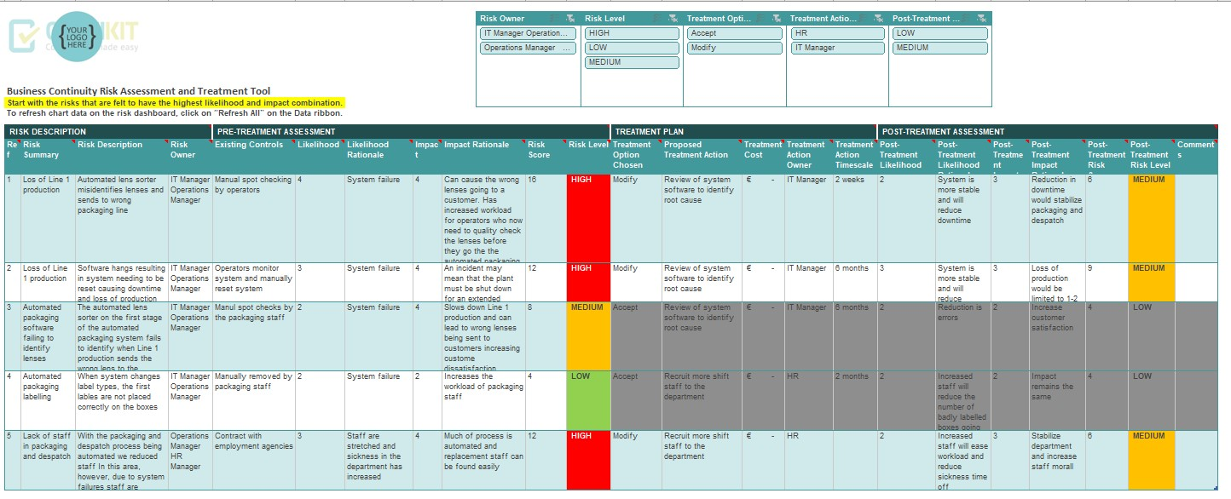
Figure 1: Screenshot of the risk assessment tool

